Technical report of project Bio & Health

## **Andreas Nalmpantis – 3699, Ioannis Oikonomidis – 3668,**

## **Chris Papakonstantinou – 2499, Iordanis Kokkinidis – 3412**

## **1st of April 2022**

# Introduction

This is the second part of our 3-part project. In this stage we completed the front-end side of our website. The technologies that were used were HTML, CSS, JavaScript and Bootstrap to help us make the website responsive. In this report, a quick description of each page of our website will be given, describing each page’s main functions, our thought process and what remains to be done in the third part, in which we will develop the back-end for our site.

Most of the pages use Bootstrap 5’s class fluid container with the custom CSS class left-right- pad which adds 12% padding to the left and right and 2rem padding to the bottom. This way the elements are responsive, keep the same amount of padding on the x axis and have at least 2rem padding from the footer.

# Front End

## Navbar

The navbar is included in every file of our website. It provides some quick navigation shortcuts to the user and some links to pages related to the user’s account.

First, it contains a “hamburger” menu which, when clicked, reveals a list of links for every product category in our store (these categories are not yet final, they may change once the back-end is complete). When the users click one of these links, they will be transferred to a different page which will display all the products of the selected category.

The above happens when the account viewing the page is signed in as a user, when the account is signed in as an admin, the “hamburger” menu shows a list of admin exclusive pages the admin can be redirected towards. Those pages are AdminPendingOrders.html where the admin can see the pending orders, AdminNewProduct.html where the admin can create and add a new product to the site and AdminSearch.html where the admin can edit and delete existing products.

Then we have the Bio & Health logo. It is a link which acts as a home page button.

After that, there is a search bar. The users can type in the product they are looking for, or keywords related to what they are looking for, and they will be transferred to a different page, UserSearch.html if they are logged in as user or AdminSearch.html if they are logged in as admin, with the results depending on what they typed.

In the end, there are 3 icons, the “account” icon, the “cart” icon, and the “favorites” icon. The account icon contains a dropdown menu, with links that provide the way for the user to sign in or create a new account, or (if he is already signed in) to edit his account information and log out. The cart icon opens the cartpage.html file, which displays the products that the users have added to their cart and the favorite icon opens the favorites.html page which displays the products that the users have added to their favorites. The cart and favorites icons are shown only on the pages users can access and not in the admin exclusive pages since they are not needed in those.

To create the navbar, we used plain CSS and Bootstrap for the layout and some utilities.

Here is the navbar shown when logged in as a user:



Here is the navbar shown when logged in as an admin:



Here is the navbar shown when not logged in:



## Footer

It is also included in every page and is located at the bottom of it. It contains some general information about the store and several ways of contact.

The first section under the “Contact” heading has some contact information along with the link “contact form” which takes the users to the contactForm.html page in which they can write a message to the administrators.

The second section contains location information for our store and the last section contains links for our social media accounts (currently the social media icons lead to the homepages of the respective social media sites). Both the icons in the header and the footer are taken from [font awesome](https://fontawesome.com/) and so are all the other icons used in any page.

The “Contact Form”, “More Info”, “Terms of use” and “Personal data” all are only present in the pages the users can see and not in the admin exclusive pages since the admins have no use for these links.

The “Terms of use” and “Personal data” also currently link to the UserMoreInfo.html page instead of actual terms of use or personal data policy documents.

To structure the footer and make it responsive, we used the Bootstrap grid layout (classes row and col)

Here is the footer shown when logged in as a user:



Here is the footer shown when logged as an admin:



## Index.html

The home page of our website. It contains various links and media content for the user.

At the top of the page there is a slideshow, which will contain some representative content for different parts of our website and will link to them, giving those parts more visibility and providing easier navigation for the user. The content will be filled during the third stage of the project, when all the products will be added.

In the middle we have a section which displays all the product categories that we have in our store. Both the images and the text are links which will take the user to the search page, displaying all the products of the selected category.

Lastly, we have some more representative content for different things, such as new products, offers, and some useful information regarding our store.

For the layout of the page, we used the Bootstrap grid and flexbox. For the slideshow, we used the Bootstrap class “carousel” along with all its subclasses. For styling, in this page and all the pages, we used plain CSS and Bootstrap utilities.

The current images are just placeholders and will get replaced later on.

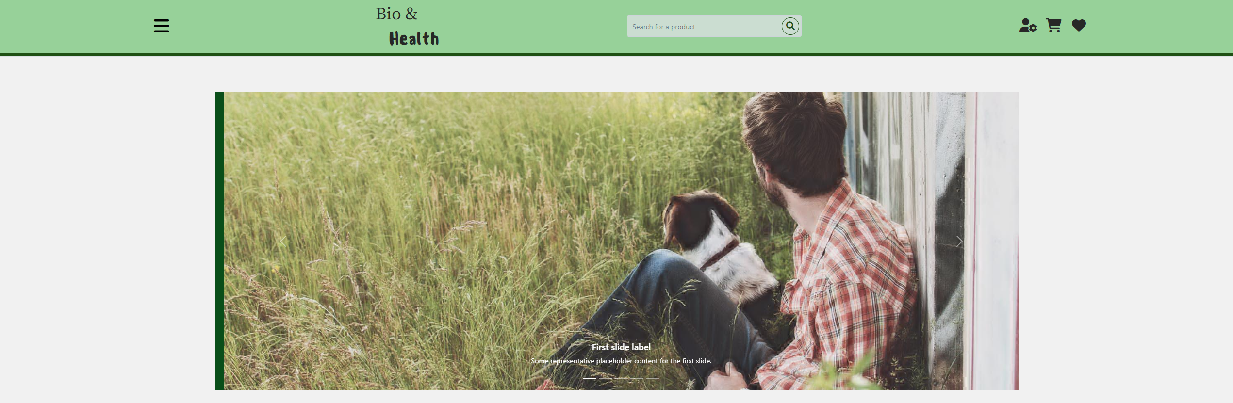

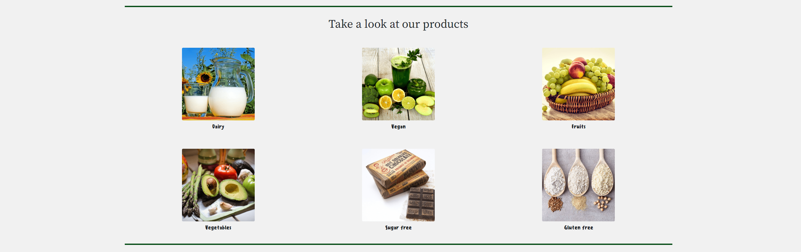

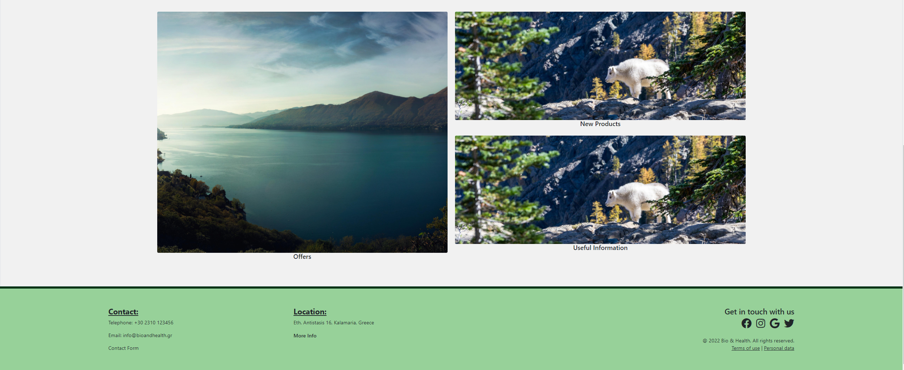

## AdminCart.html

This page shows the admins the information of an order that a customer made. It shows all of the information the customer inputted when making the order using the UserCheckoutPage.html as well as all of the items that the user’s cart was held when the order was made including their amounts, their total prices and the user’s shipping choice.

The admins can go back to the page that shows all of the pending orders by clicking the “Back to orders” button located on the right side of the page.

This page was build using bootstrap 5 and mainly rows and columns. There are two sections, one for the billing address and payment which is made up of two rows, the top of which is split into half with each half containing labels and input fields similar to the UserCheckout.html page.

The other sections if for the order’s cart and is a row split into a col-8 and a col-4 with an internal layout similar to the UserCart.html page.

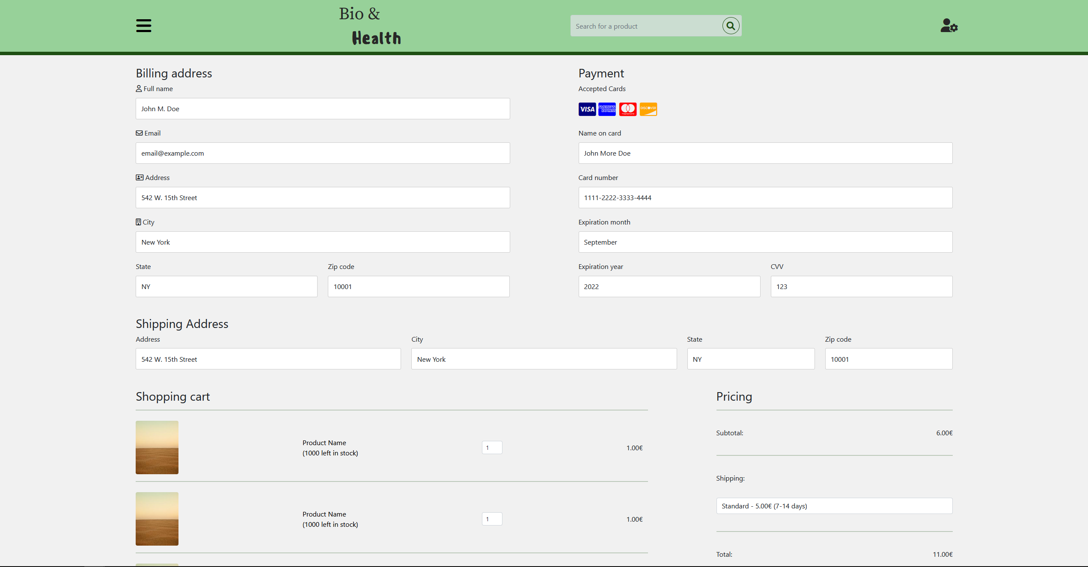

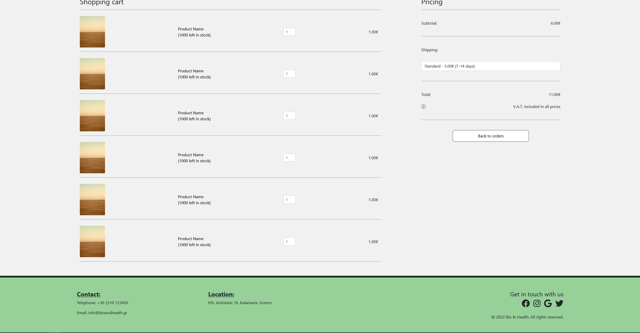

## AdminEditProduct.html

Page in which the admis can edit the information of a product, in case something has changed, or they made a mistake.

Both the new product and edit product are structured using Bootstrap grid and flexbox.

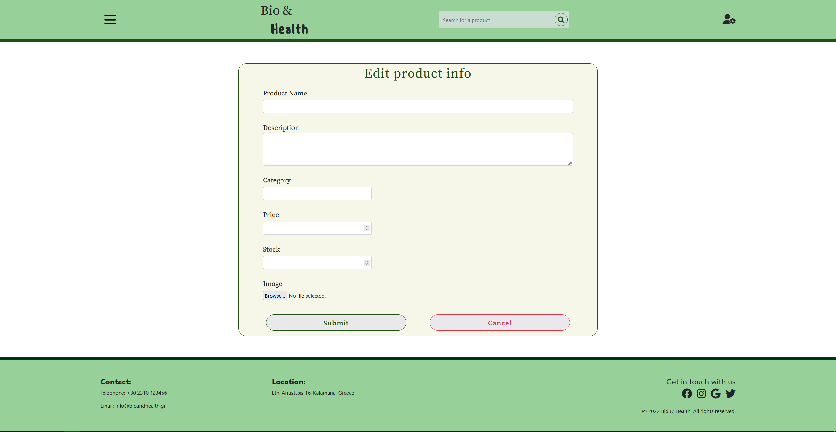

## AdminIndex.html

This page is similar to the home page Index.html with the difference that it is the home page the admins see when logged in as admins and it has different options on the navbar “hamburger” menu which allow them to perform administrative actions.

The page is built using the exact same layouts as the Index.html page.

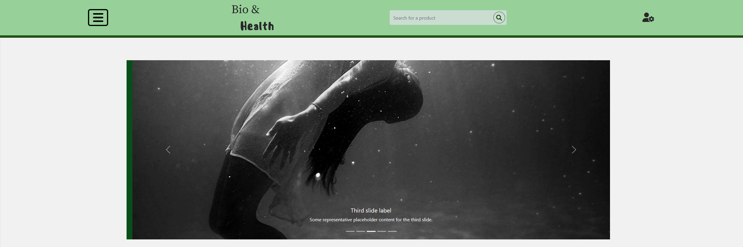

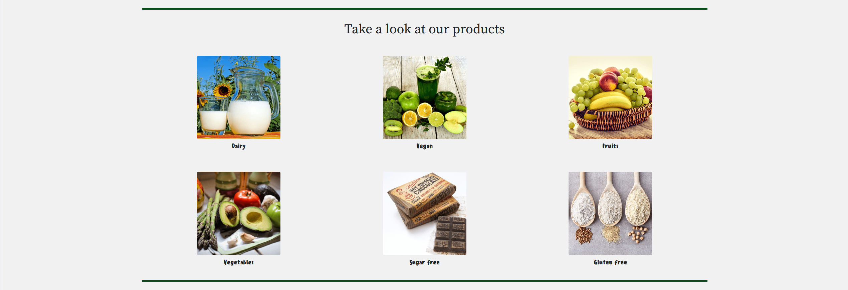

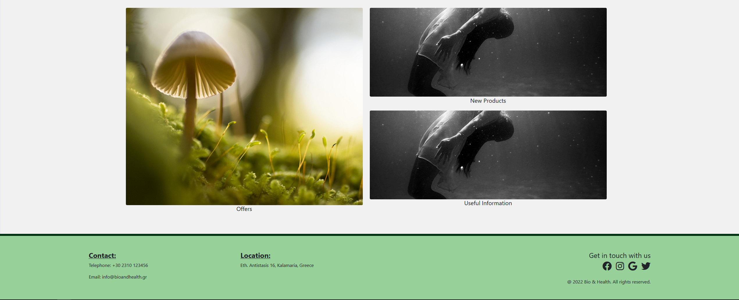

## AdminNewProduct.html

In this page, the admins will be able to add a new product for the store by typing the required information in the form and submitting it. The page also contains a list of the product categories available and an option to add a new category.

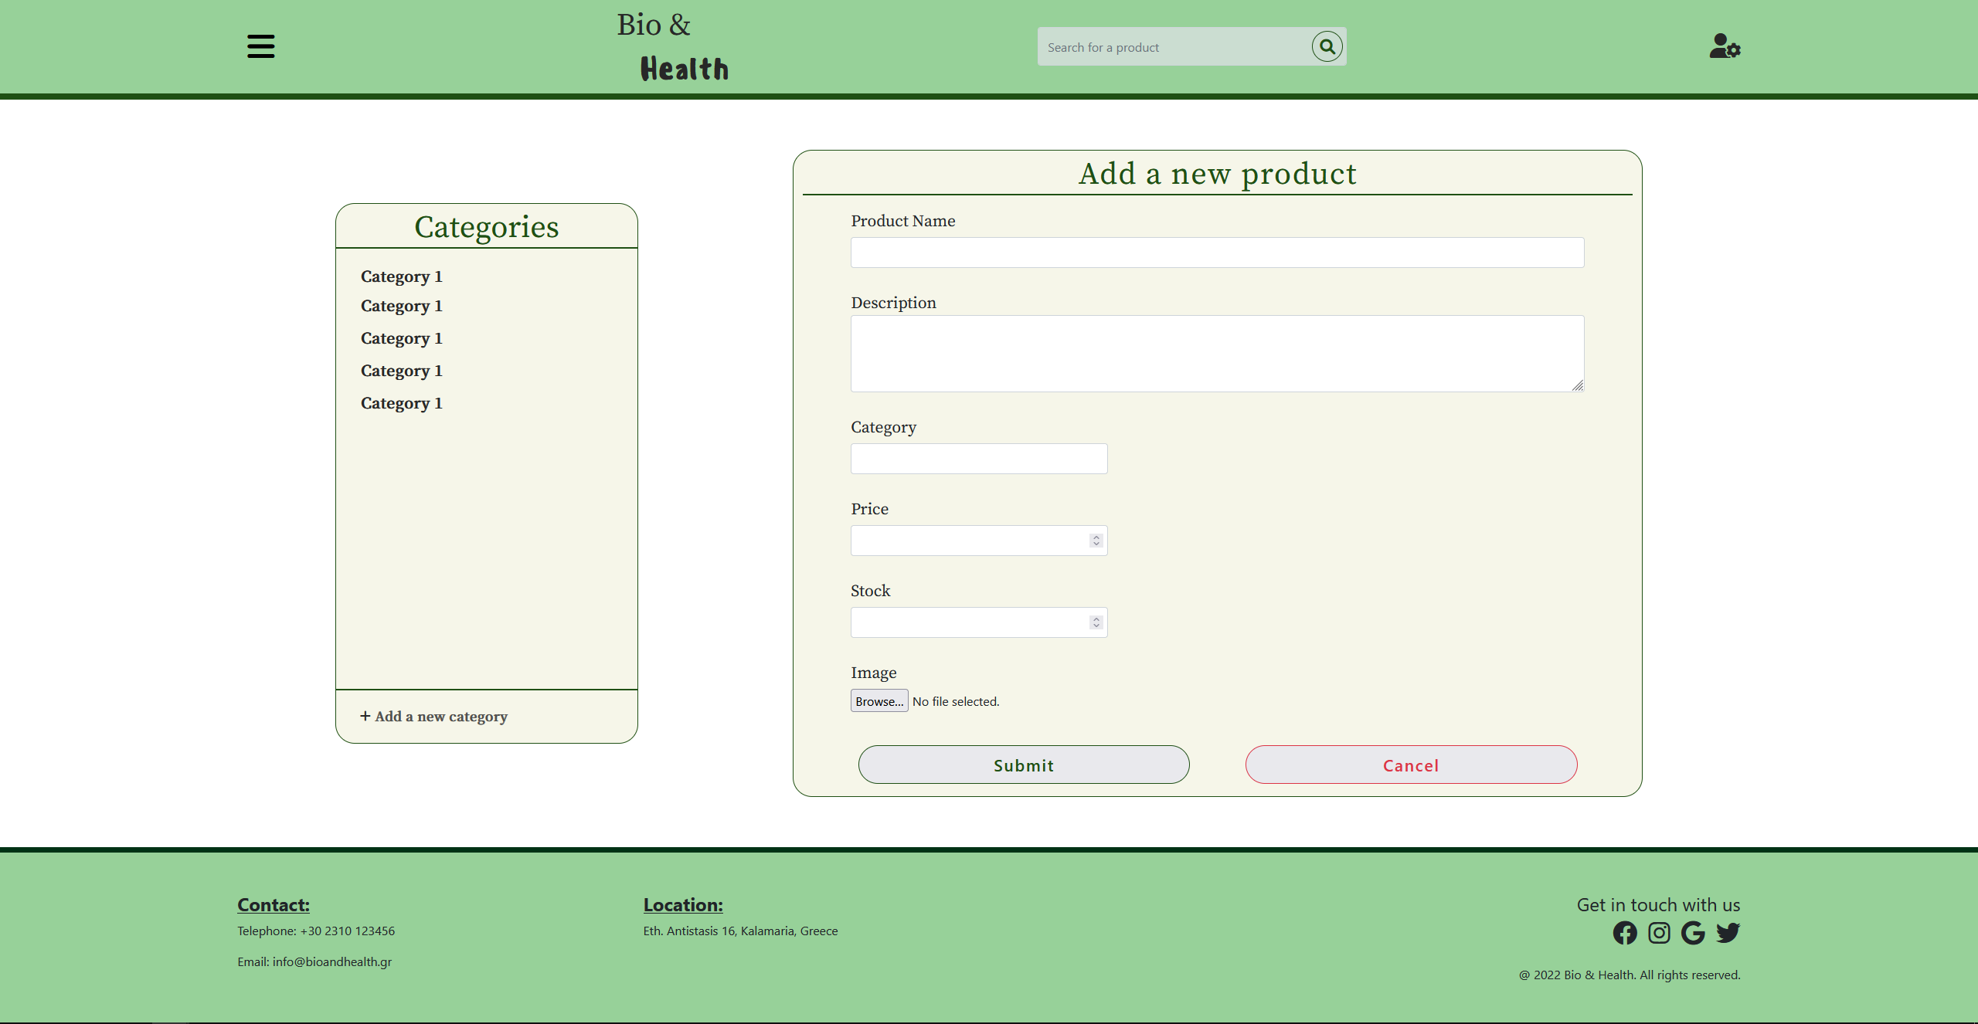

## AdminPendingOrders.html

In this page the admins can see the pending orders submitted by the users. The available info about the orders on this page is the order ID, the username of the user who made the order, the submission date of the order, the date it has to have been delivered by and its total cost.

By pressing the “Details” button of one of the orders, the admin be redirected to the page AdminCart.html which shows all the information of the specific order. Additionally, by pressing the “Complete” button for one of the orders, that order is marked as complete and is removed from the list of pending orders. For now, this button only sets the corresponding row’s inner html to empty but once the back-end is complete, it will remove the said order from the list of pending orders.

The page’s layout is constructed using Bootstrap 5 and the responsive table class with the classes *thead* and *tbody* for the elements of the table.

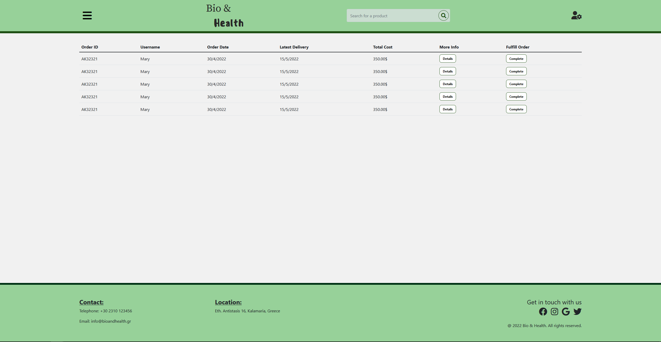

## AdminSearch.html

Using this page, the admins can search for and select products to edit or delete from the database. More specifically, the products showed can be filtered to show all products or only products that belong to a specific category using the “Show only:” dropdown menu. The products can also be sorted based on specific characteristics they have using the “Sort by:” dropdown menu.

The two menus mentioned above have no effect as of right now, but once the back-end is complete, they will be fully functional. As we can see in the figure that follows, for every product the admins can see their name, amount in stock, cost and the categories the product belongs to (the categories are represented by the colored “i” icons which will likely change to more fitting icons in the third part).

The image shown for each product are randomly selected placeholders until we have a working back-end which will provide each product image, name, etc. There are also two buttons per product, the “Edit” button which redirects to the AdminEditProduct.html page which allows the admins to edit the specific product’s info (this redirect also happens by clicking on the product’s image) and the “Delete” button which upon being clicked opens a modal pop up asking the admin if they are sure they want to delete the product from the database.

This pop up has a “Delete” button which permanently deletes the product from the database and a “Cancel” button which cancels the deletion.

The page’s main layout for the products uses a grid layout containing many smaller fluid containers with the information of each of the products. That information itself is controlled using Bootstrap 5’s rows and cols.

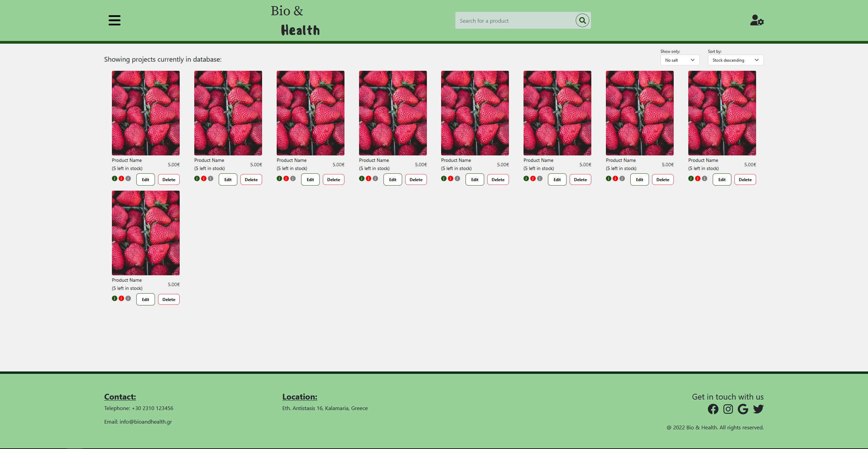

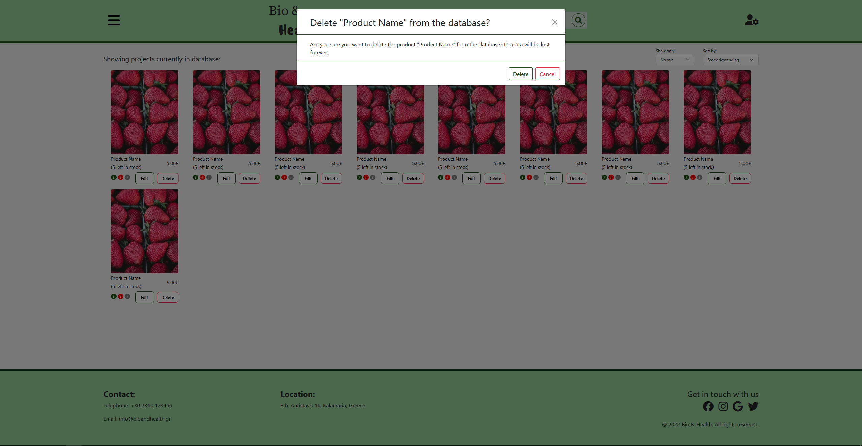

## AdminSignIn.html

This page is where the admins sign in. They type their credentials in the given form and submit it. They can also sign in as customers by clicking the “Sign in as Customer” button which redirects to the corresponding page and they can go to the user sign-up page by clicking the “Sign Up” button.

For the layout we used the Bootstrap grid, and flexbox.

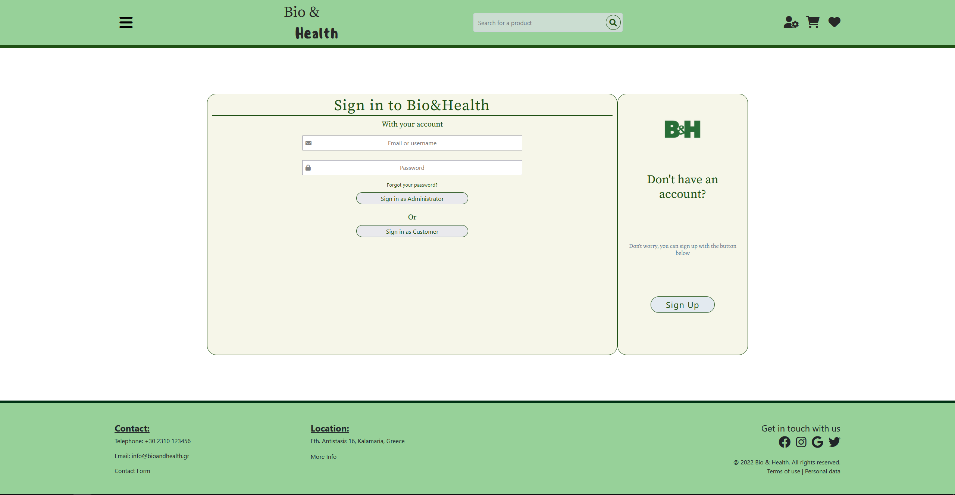

## UserAccountInfo.html

In this page, the users can edit their account information. The input fields, when the back-end is complete, will display the information given by the user and they will then be able to change it by editing the fields and submitting the form.

The layout used for this page has mainly been flexbox.

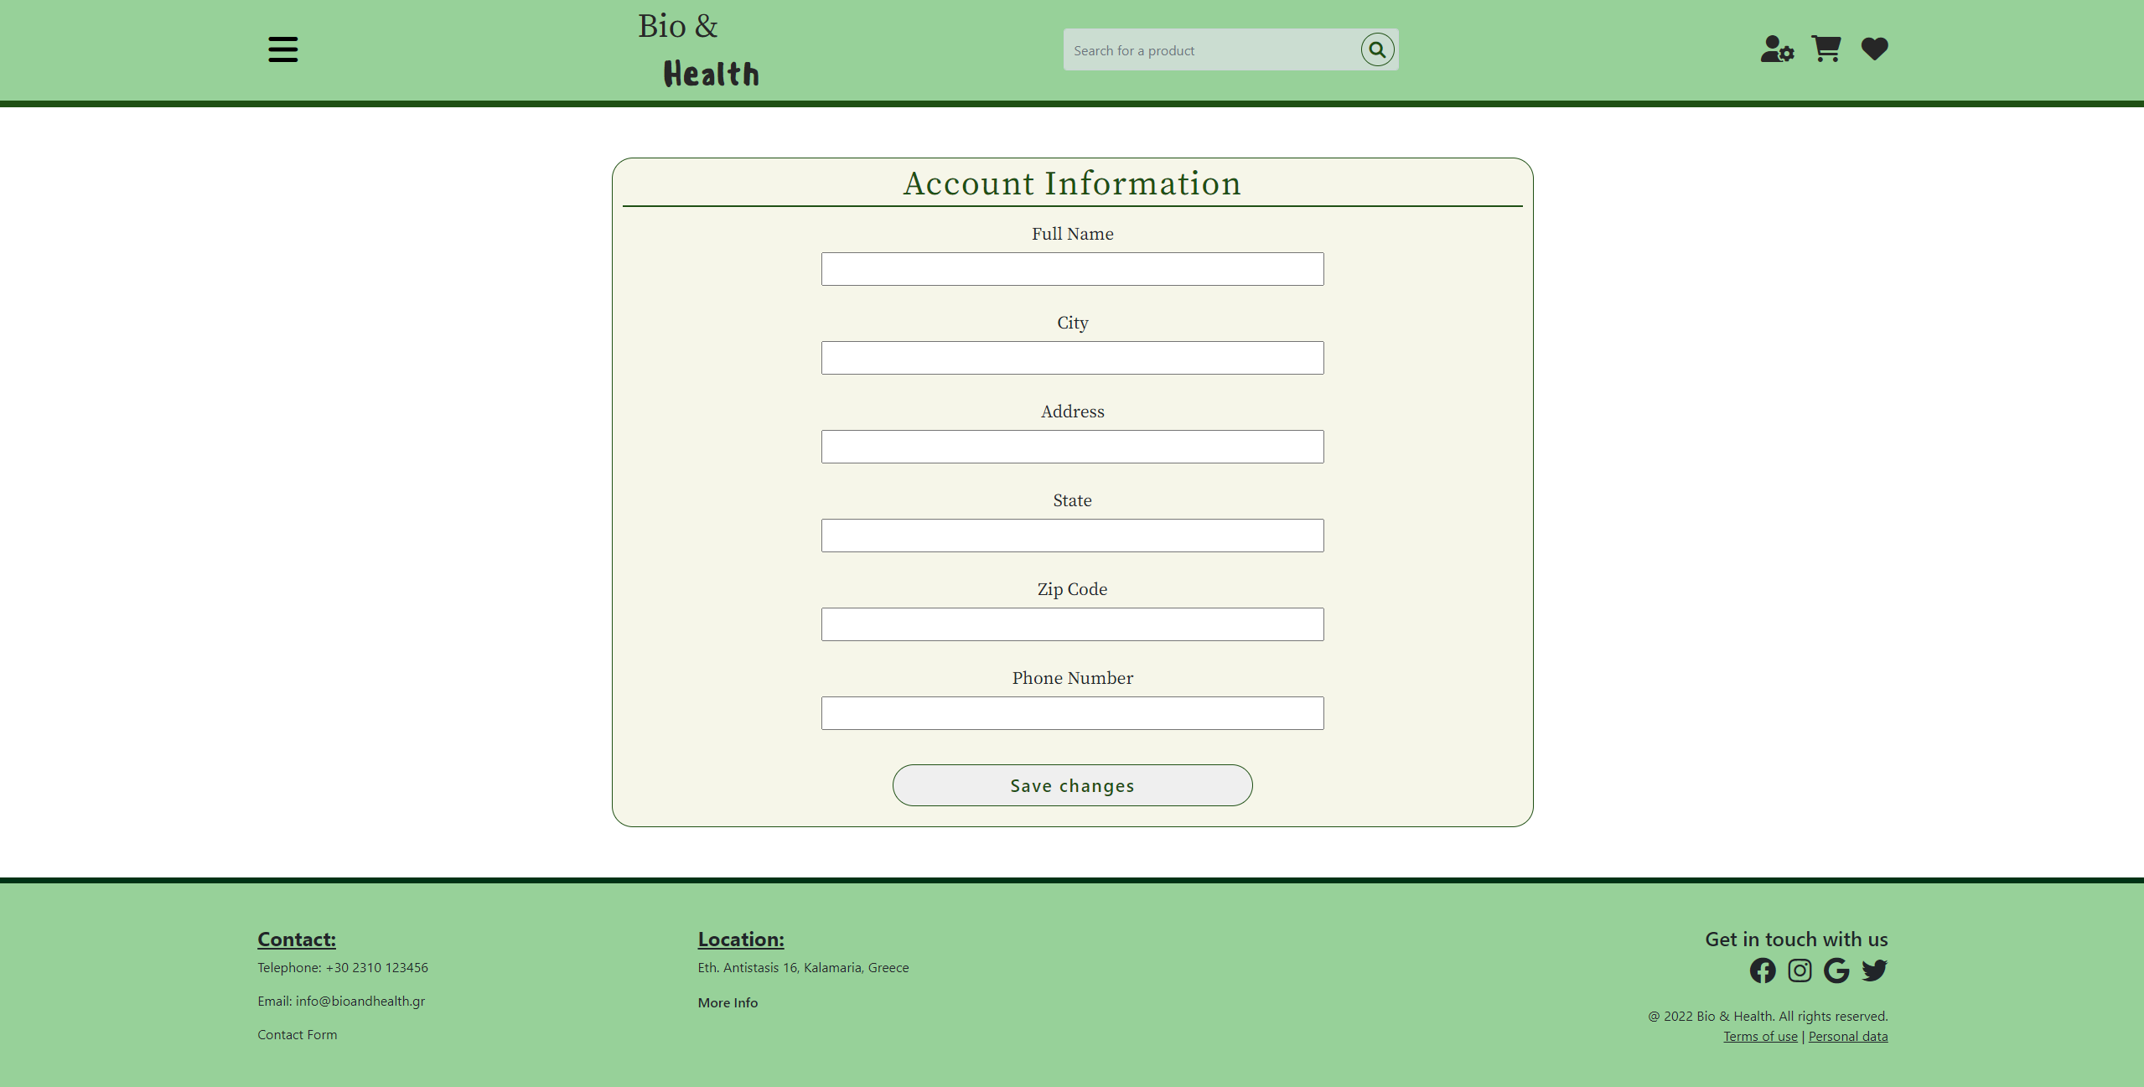

## UserCart.html

This page shows the users the current content of their cart. For each product in the cart it shows its name, the amount of stock left, the quantity which can be adjusted, its total price and a button to remove the product from the cart.

Additionally, by clicking on the product’s name, the users are redirected to the corresponding product’s information page UserProductInfo.html.

On the right side of the page there is a pricing summary which gets dynamically updated using Javascript and an option for the users to pick their shipping type.

Lastly, there is a proceed to checkout button which leads to the checkout page UserCheckout.html page where the users can complete their order by inputting their payment details.

The layout of the page is made using a main row split in one col-8 part which holds each product’s details, the details are inside a horizontal d-flex container and, and a col-4 part which holds the pricing details in horizontal d-flex containers.

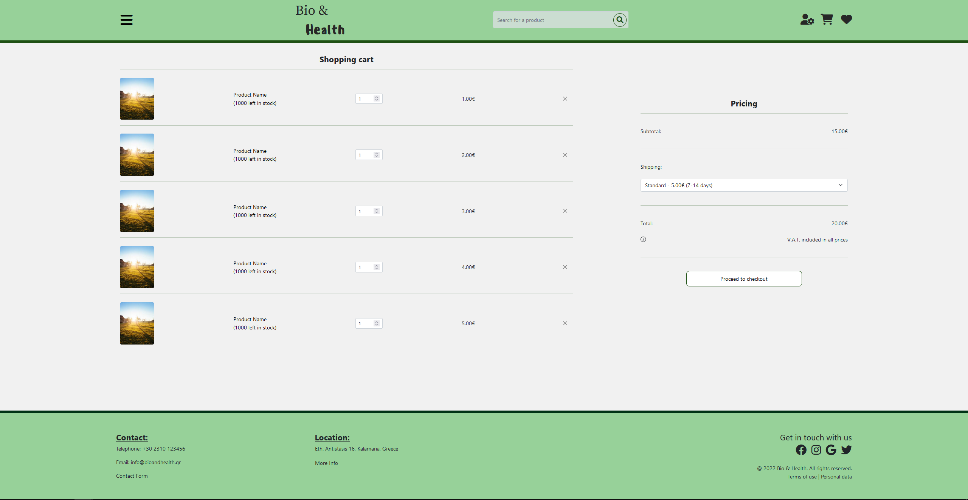

## UserCheckout.html

This page is the one where the users input their payment details so that they can complete their orders. In the top part of the page there are two columns, one for the billing address of the user and one for the payment details that concern the card the user will pay with.

Then in the shipping address department, if the “Same shipping address as billing” box it ticked, the billing address is used as the shipping address, while if it is not ticked, a new address must be inputted the input fields that appear.

On the bottom part of the page we have the total cost of the order, the “Place order” button which upon clicking submits the form and redirects the user to the UserOrderCompletion.html and the “Back to cart” button which redirects the user back to the UserCart.html page without submitting the form.

The layout of the page is once again based on Bootstrap 5’s rows and columns using two col-6 elements inside a row element to display the billing address and payment details. Then the rest of the elements’ layout is made using rows.

Each input field has the required attribute and has a specific regular expression patter using the pattern attribute so that only correct input can be saved successfully.

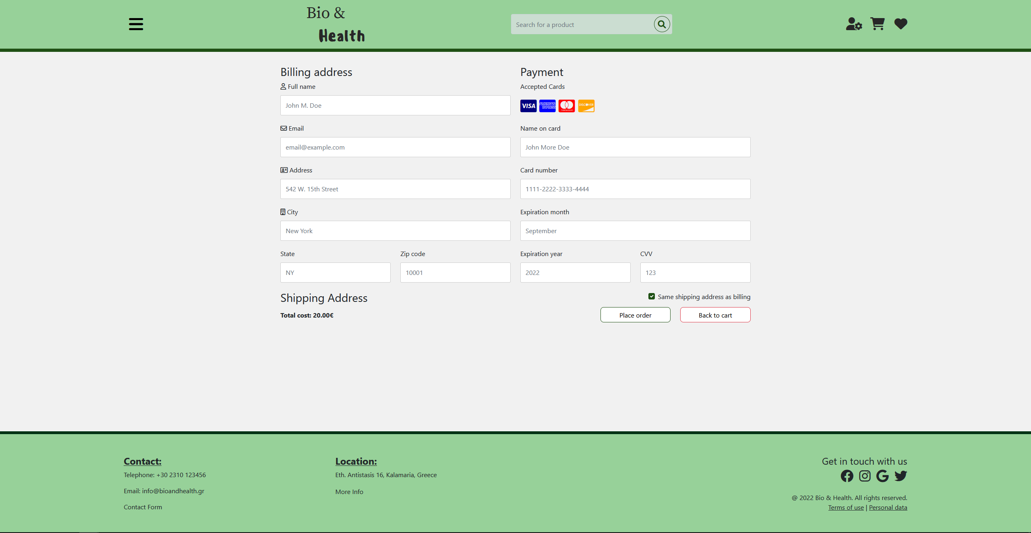

## UserContactForm.html

This is the page where the user can fill a contact form and submit it to the administrators of the website/e-shop. The main section of the page contains a <form> element that the user can fill out. The form has fields for the user’s name, email address, a <select> element with various topics and a <textarea> element for the user’s message. Below those forms is a submit button, that once clicked sends the user the UserContactFormCompletionl.html page, but in the future (once we work on the backend of the project) will also send the information from the form to the backend using php.

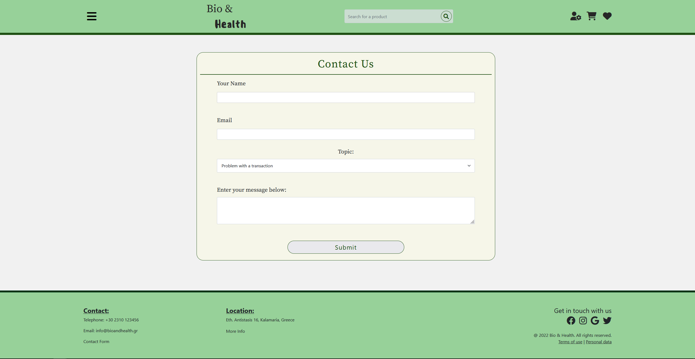

## UserContactFormCompletion.html

This is the page where the user is redirected from UserContactForm.html after he submits a contact form. It is a simple webpage with a message to the user and an html <button> element, that redirects the user back to the homepage/index.html. The user can also use the header (or navbar) and the footer to navigate elsewhere on the website (i.e., click on the logo to return to the homepage).

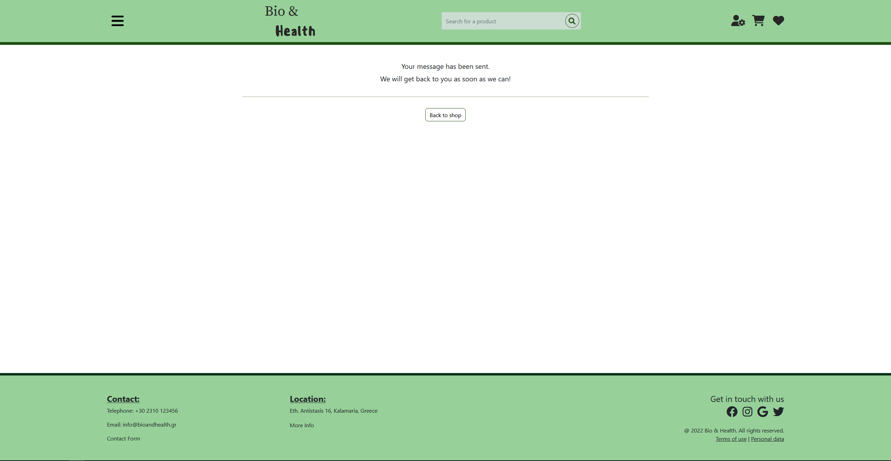

## UserFavorites.html

The favorites page contains a table of the favorite products of the user, together with information about these products. For each one of the favorite products, the page shows the product’s name and its price. The layout of the page is created by using the table tag of HTML5 and tr and td tags to declare the rows and the content of all the cells of the table. Users can visit the favorites page when they click on the small heart shown on the right side of the navbar shown on all user pages.

When the user clicks on the picture of a products, then the page containing detailed information about the product appears, as it is described in the UserProductInfo.html page section of this report.

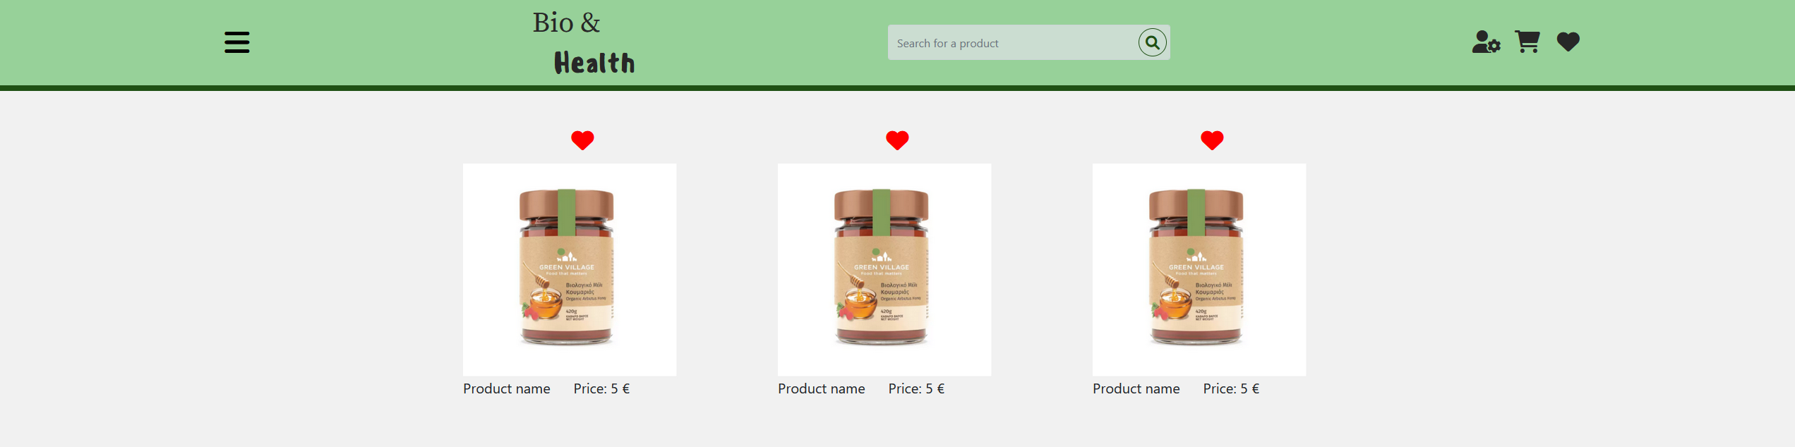

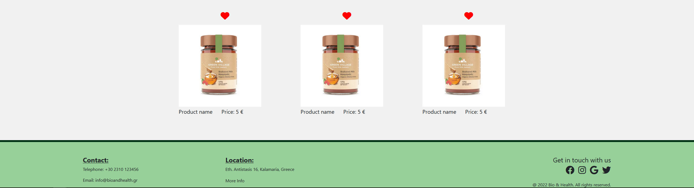

## UserMoreInfo.html

This is the web page where the visitor can get information about our e-shop and our products. Like every other web page, it has a header and a footer. The page contains a grid of bootstrap rows and columns, with headers and paragraphs. Each Header is the title of a topic (i.e. About us, Local Producers etc.) and each paragraph is a Lorem Ipsum placeholder text. Each row ends with a <hr> so that a horizontal rule appears on the page to separate each section, since it is a different topic.

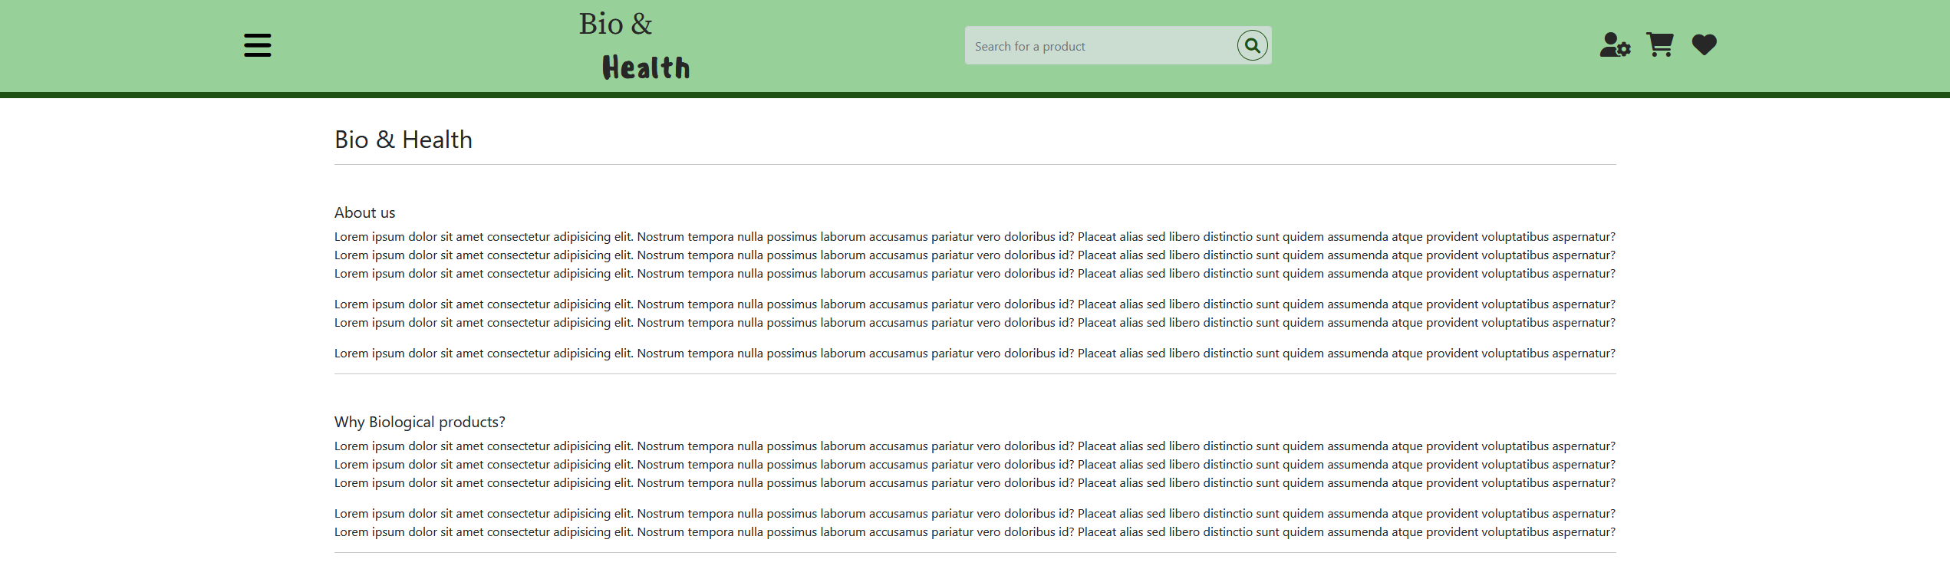

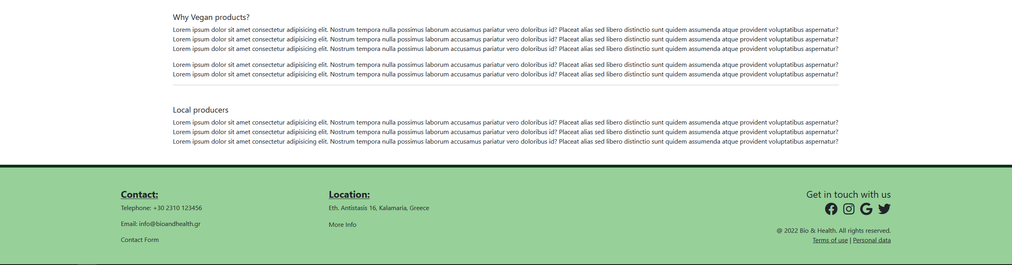

## UserOrderCompletion.html

This is a page that shows a message to the users after they have successfully completed an order with the order’s ID and a thank you for choosing us message. The “Back to shop” button redirects the user to the Index.html page with is the home page of the site.

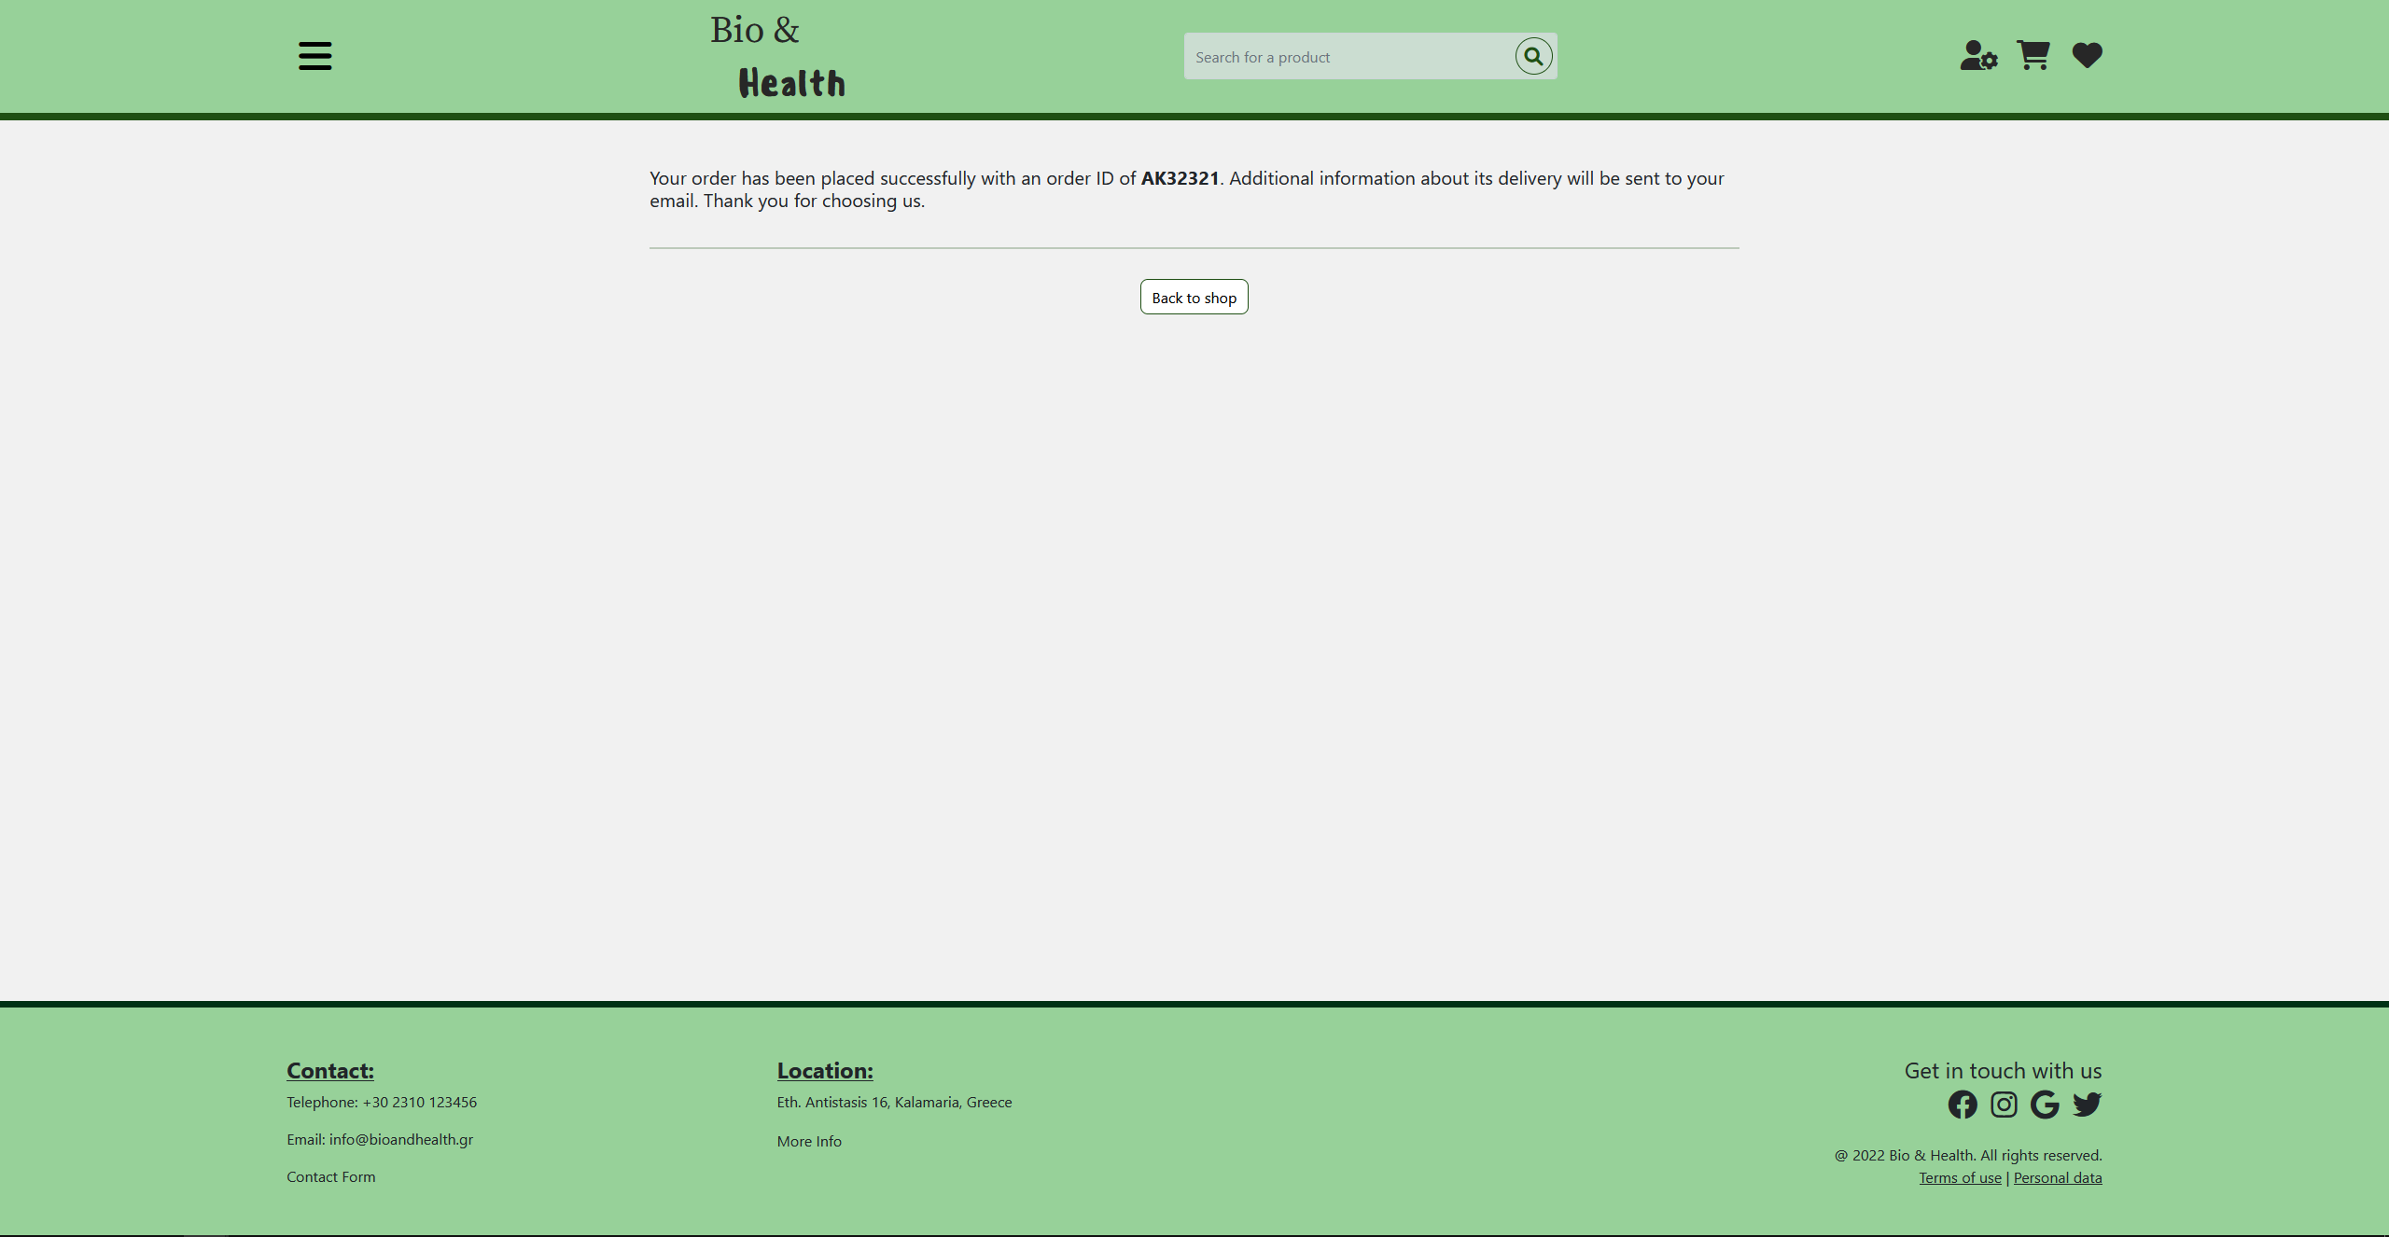

## UserProductInfo.html

The product information page contains detailed information about a product. Τhe information contains the product’s picture on the left side and other useful information about the product on the right side. For every product, the information depicted contains elements like the product’s name, the weight, the price of the product and the amount of stock available, together with the description of the product.

The user can click the cart picture to add the product to the cart or the heart picture to add the product to the favorites or to remove it from the favorites list. The layout of the page was developed using the Bootstrap library.

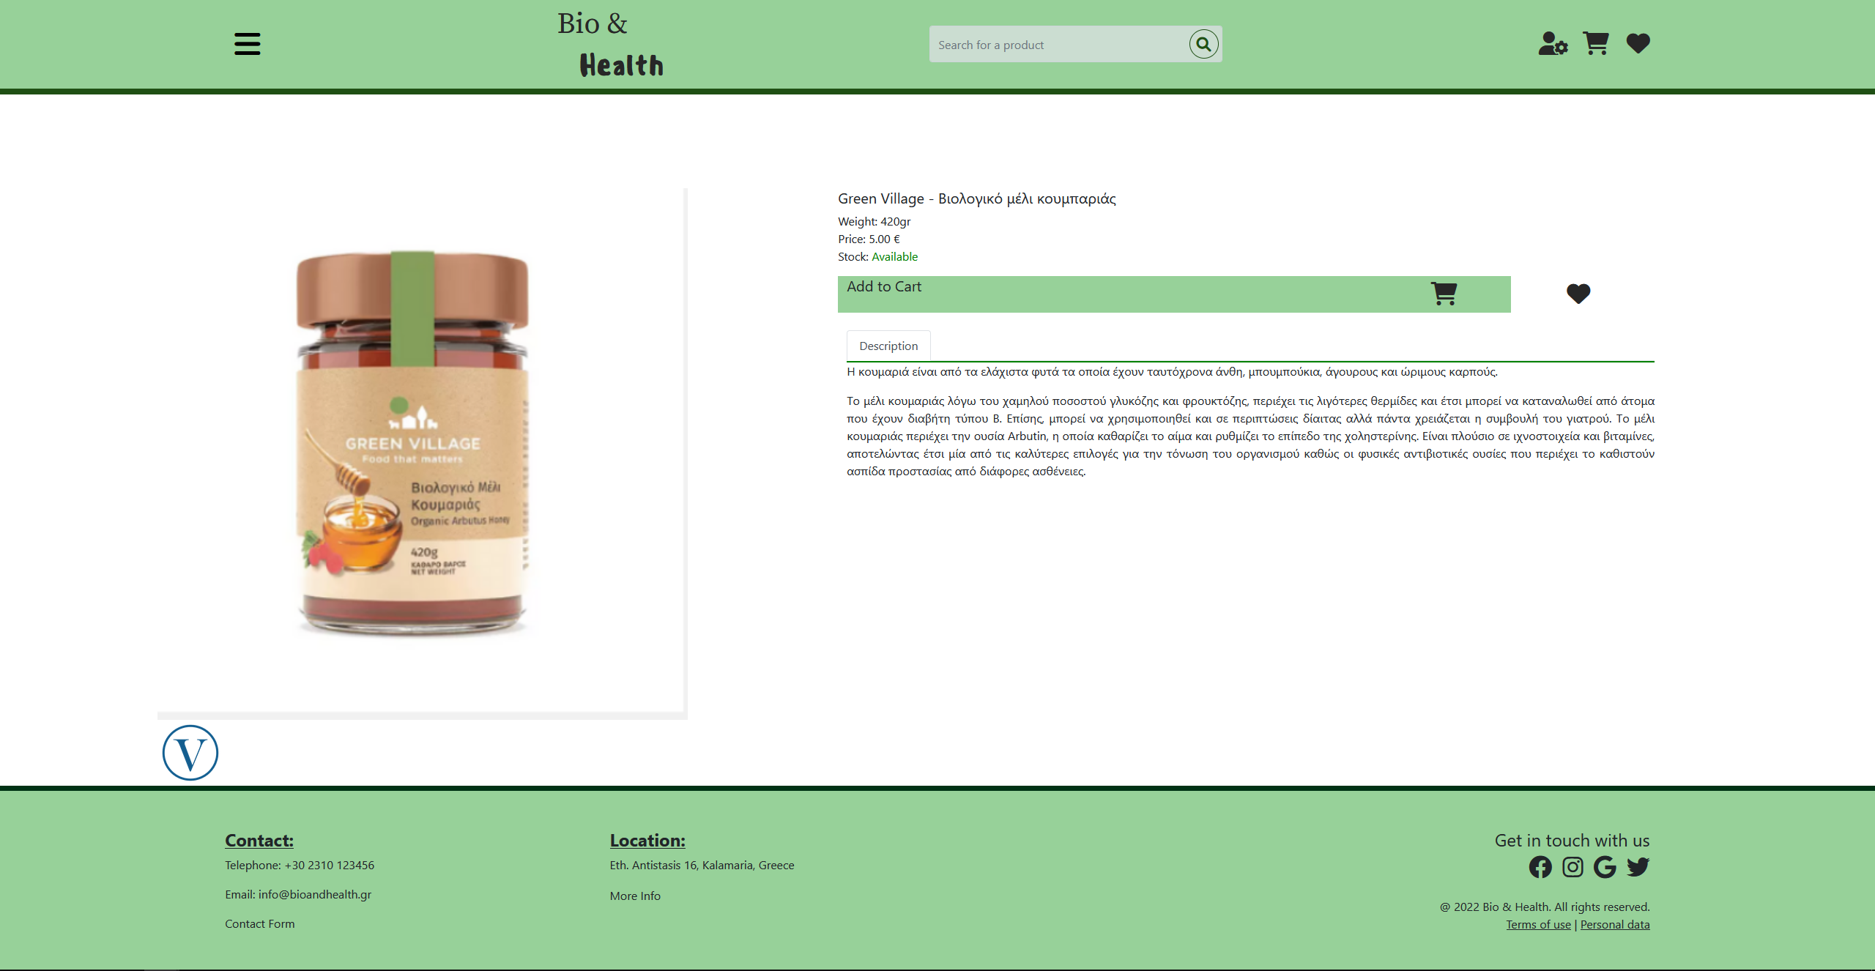

## UserSearch.html

Using this page, the users can search for products by inputting their names or key words in the navbar’s search bar. More specifically, the products showed can be filtered to show all products or only products that belong to a specific category using the “Show only:” dropdown menu. The products can also be sorted based on specific characteristics they have using the “Sort by:” dropdown menu.

The two menus mentioned above have no effect as of right now, but once the back-end is complete, they will be fully functional. As we can see in the figure that follows, for every product the admins can see their name, amount in stock, cost and the categories the product belongs to (the categories are represented by the colored “i” icons which will likely change to more fitting icons in the third part).

The image shown for each product are randomly selected placeholders until we have a working back-end which will provide each product image, name, etc.

There is also one button per product, the “Add to cart” button, which upon the completion of the back-end will add the specific product to the user’s cart. Once the button is pressed, a modal pop up appears allowing the user to pick the amount of product they want to add to their cart.

The modal pop up itself has a number input field for the amount of product to be added to cart and two buttons on its footer, a “finish” button which adds the amount of product to the cart and closes the modal pop up and a “Cancel” button which closes the modal pop up without making any changes to the cart.

This modal pop up is independent for each product and changes to one product’s modal pop up do not affect the modal pop ups of the other products.

Additionally, clicking on the product’s image, name or amount of stock redirects to the products info page UserProductInfo.html.

The page’s main layout for the products uses a grid layout containing many smaller fluid containers with the information of each of the products. That information itself is controlled using Bootstrap 5’s rows and cols.

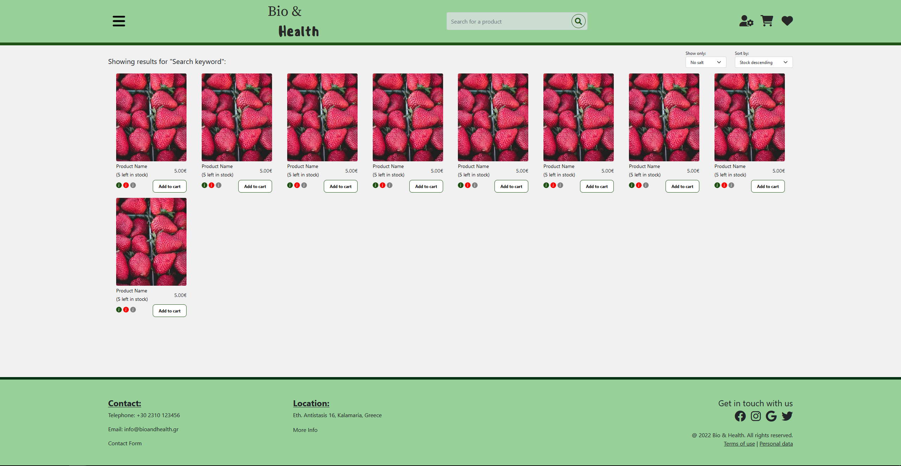

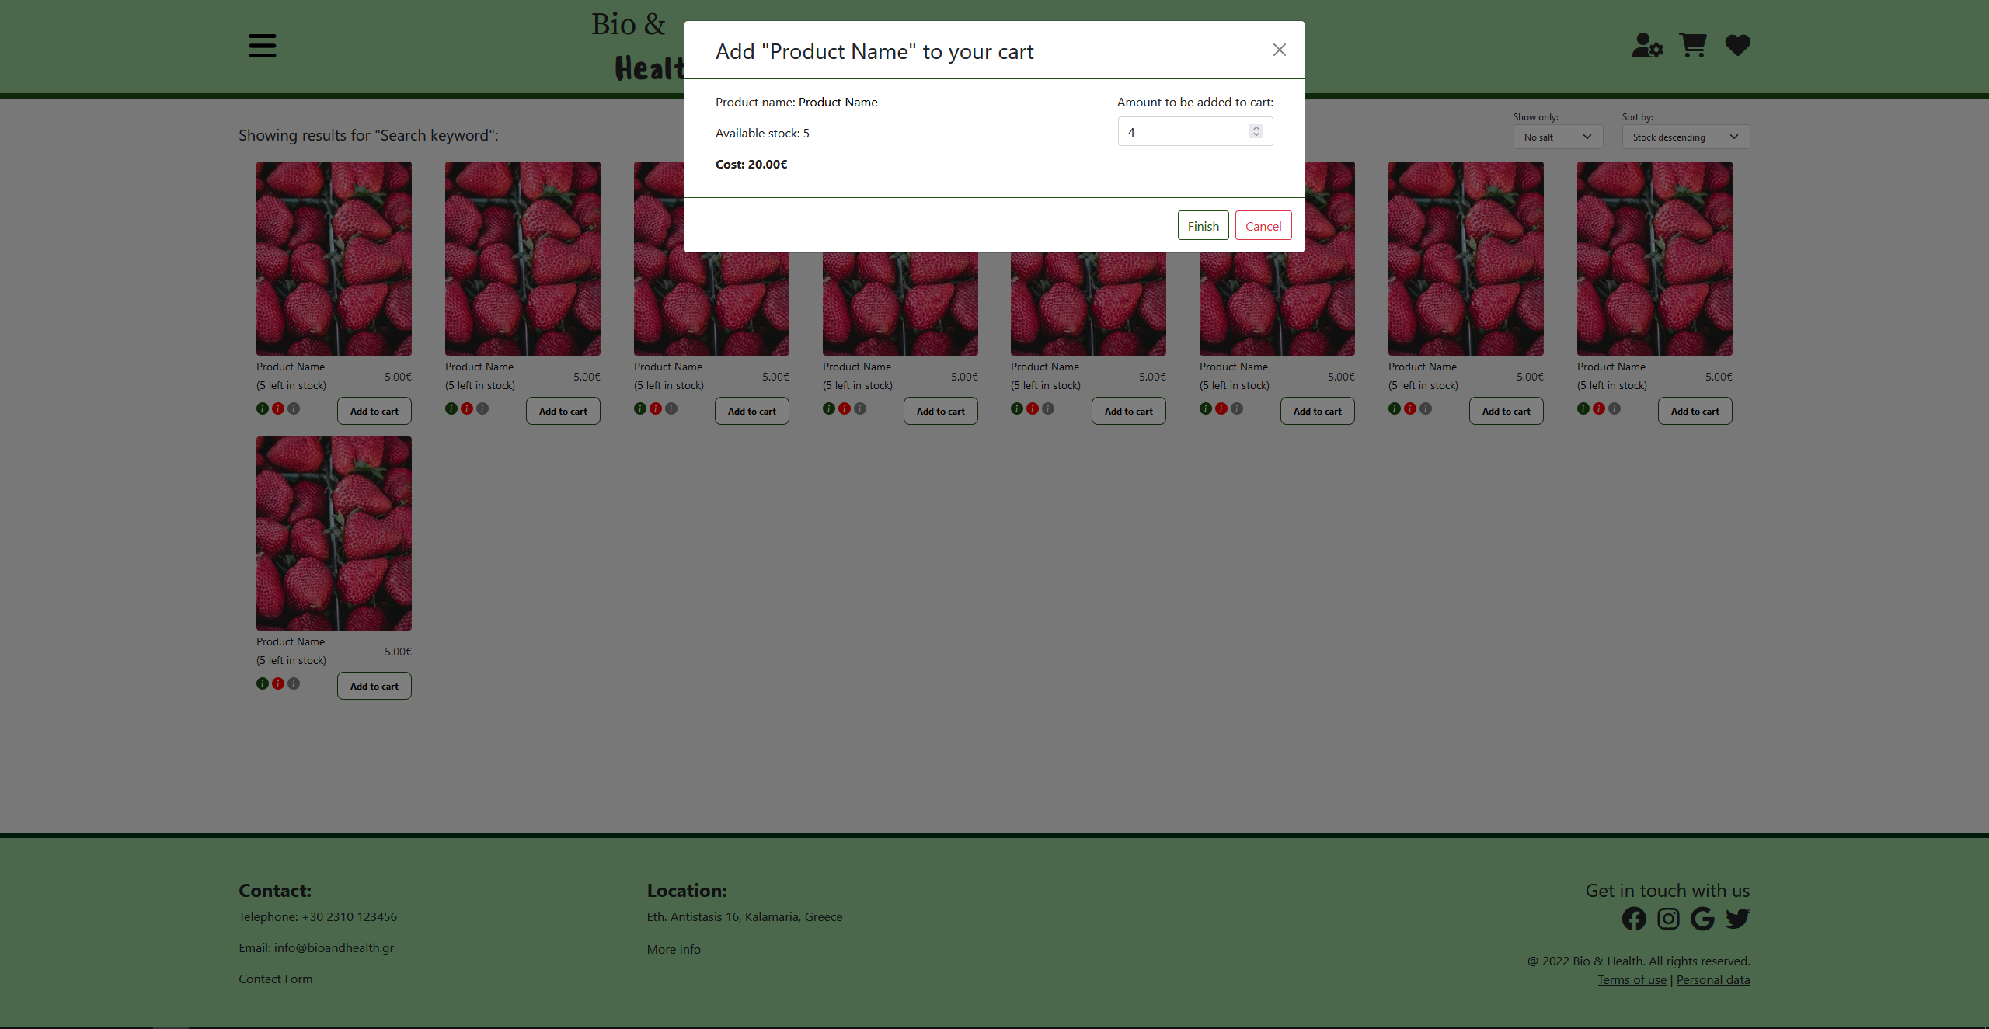

## UserSignIn.html

This page is where the users sign in. They type their credentials in the given form and submit it. They can also sign in using one of their social media accounts and they can go to the sign-up page by clicking the “Sign Up” button.

For the layout of both the Sign Up and Sign In pages, we used the Bootstrap grid, and flexbox.

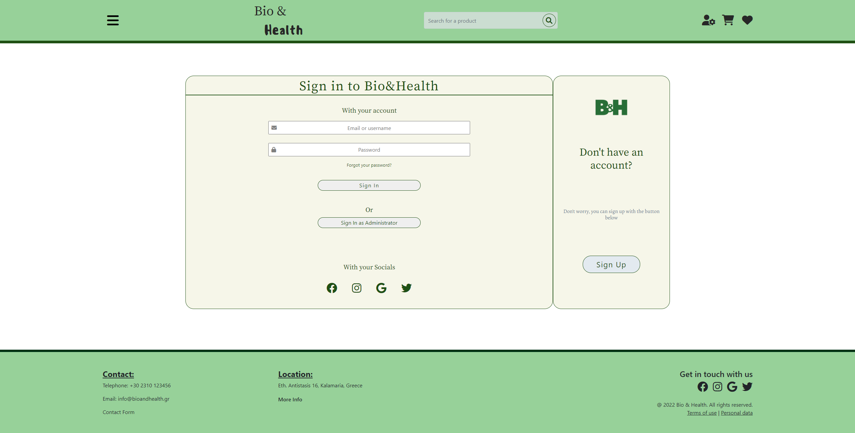

## UserSignUp.html

This is where the user creates their account. It contains a form in which the users give their account credentials (email, username, and password) and submit it. There is also the option of creating an account using one of their social media accounts.

The users also have the option to go to the sign in page if they already have an account by clicking the “Sign In” button located in the right of the page.

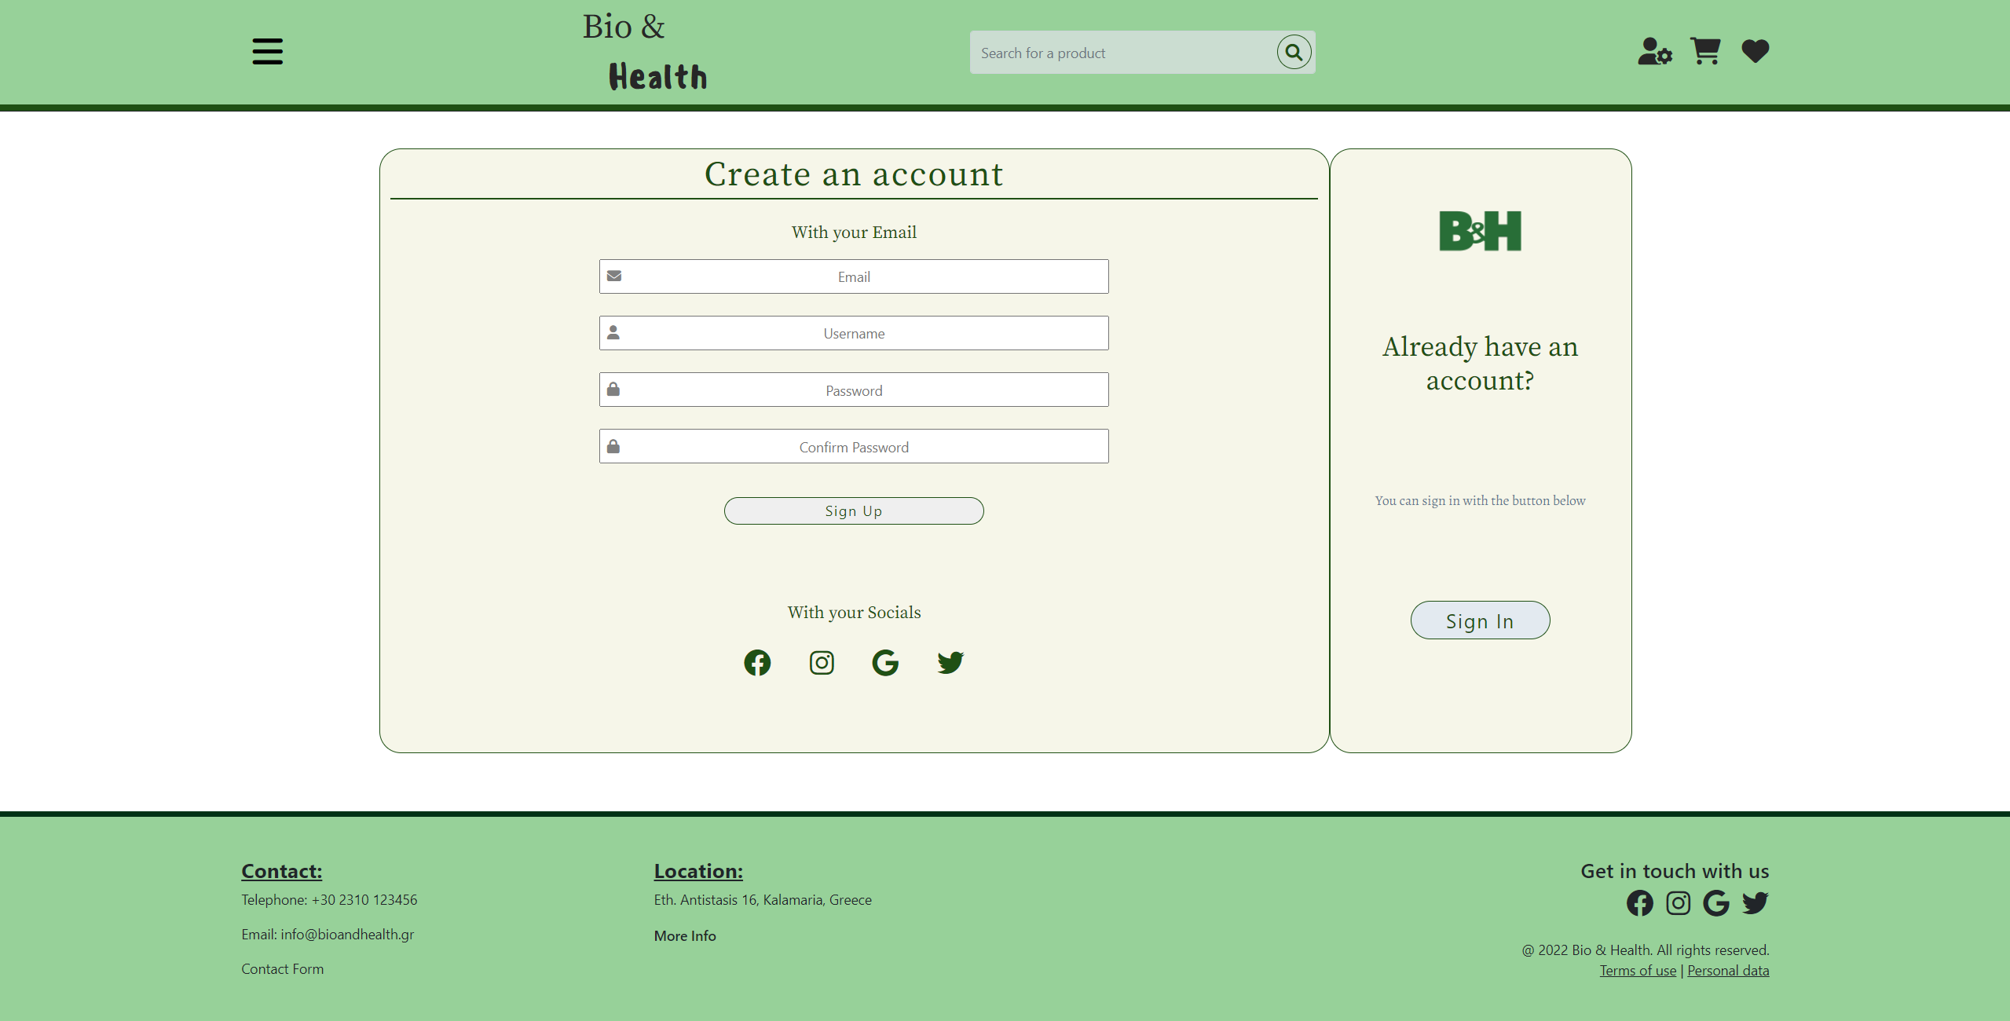

# Back End

The backend is currently under construction.